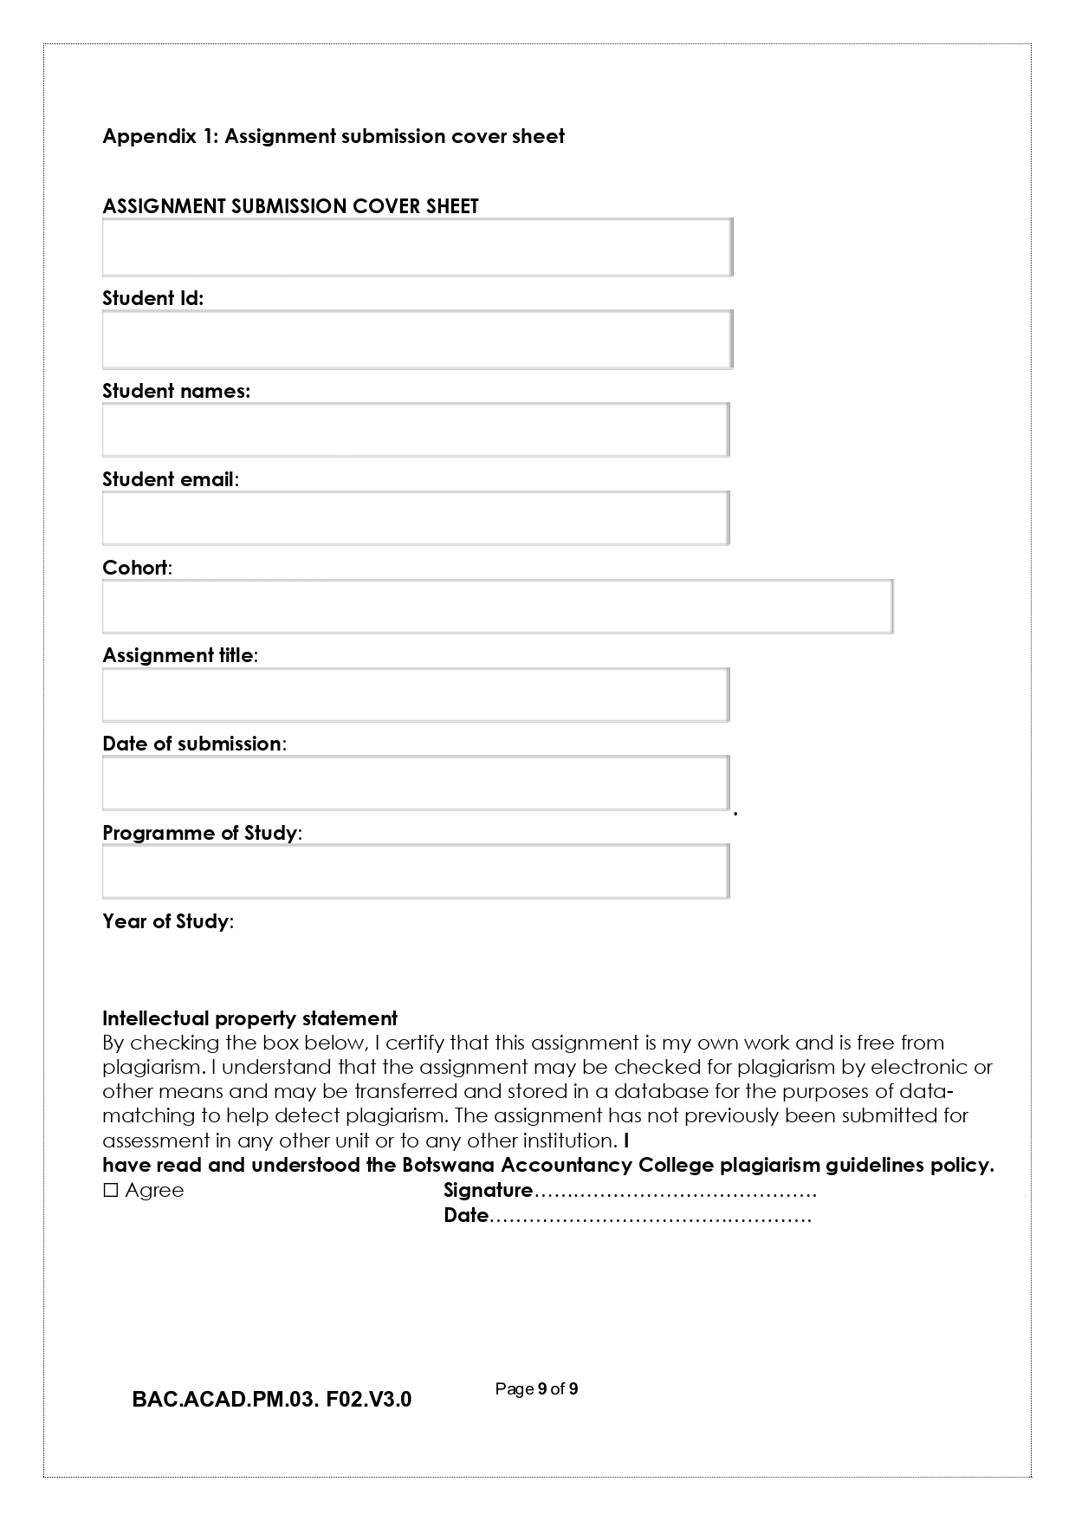
21 May 2026
A.Seboko
✔️
2025
WMD Documentation
Augustine Seboko
cse25-244
cse25-244@thuto.bac.ac.bw
2025 Year 1 Semester 2
WMD Documentation
20 May 2026
Computer Systems Engineering
Github URL link: https://github.com/Gust-32/cse25-244.git
Github repository link: https://gust-32.github.io/cse25-244/

PART A – WEBSITE PLANNING and DOCUMENTATION
1. Website Specifications
a. Website Objective and Business Goals
- Primary Objective: To develop an interactive, highly responsive e-commerce web platform for AUGY'S Style Hub that showcases retail fashion offerings (shoes and clothing) to urban consumers.
- Business Goals:
  - Digital Presence: Establish a modern digital storefront to expand reach beyond the physical shop front at the Main Mall in Gaborone.
  - Customer Engagement: Provide a fluid browsing experience that allows customers to explore collections, track their selections dynamically via local storage cart mechanics, and provide structural feedback.
  - Brand Authority: Reflect a sleek aesthetic using modern design frameworks (Bootstrap 5) to build credibility and compete effectively in the regional retail market.
b. Target Audience Demographics and Technical Aptitude
- Demographics: Young adults, working professionals, and fashion-conscious students aged between 18 and 40 residing primarily in Gaborone and surrounding areas in Botswana.
- Technical Aptitude: Low-to-moderate. Users are highly comfortable navigating mobile interfaces, social commerce platforms (Instagram/WhatsApp shopping), and basic web browser functions, but require clear call-to-actions (CTAs), prominent interactive indicators, and simple error-free navigation layouts.
c. Type of Website / Content
- Website Type: Retail E-commerce Catalog and Digital Storefront.
- Content Strategy: High-resolution product showcase blocks with descriptive text badges, structural product filtering cards, a stateful web cart architecture leveraging browser cache (localStorage), interactive client-side forms with feedback mechanisms, and contextual store layout information.
2. Information Design and Taxonomy (Site Map and Flowchart)
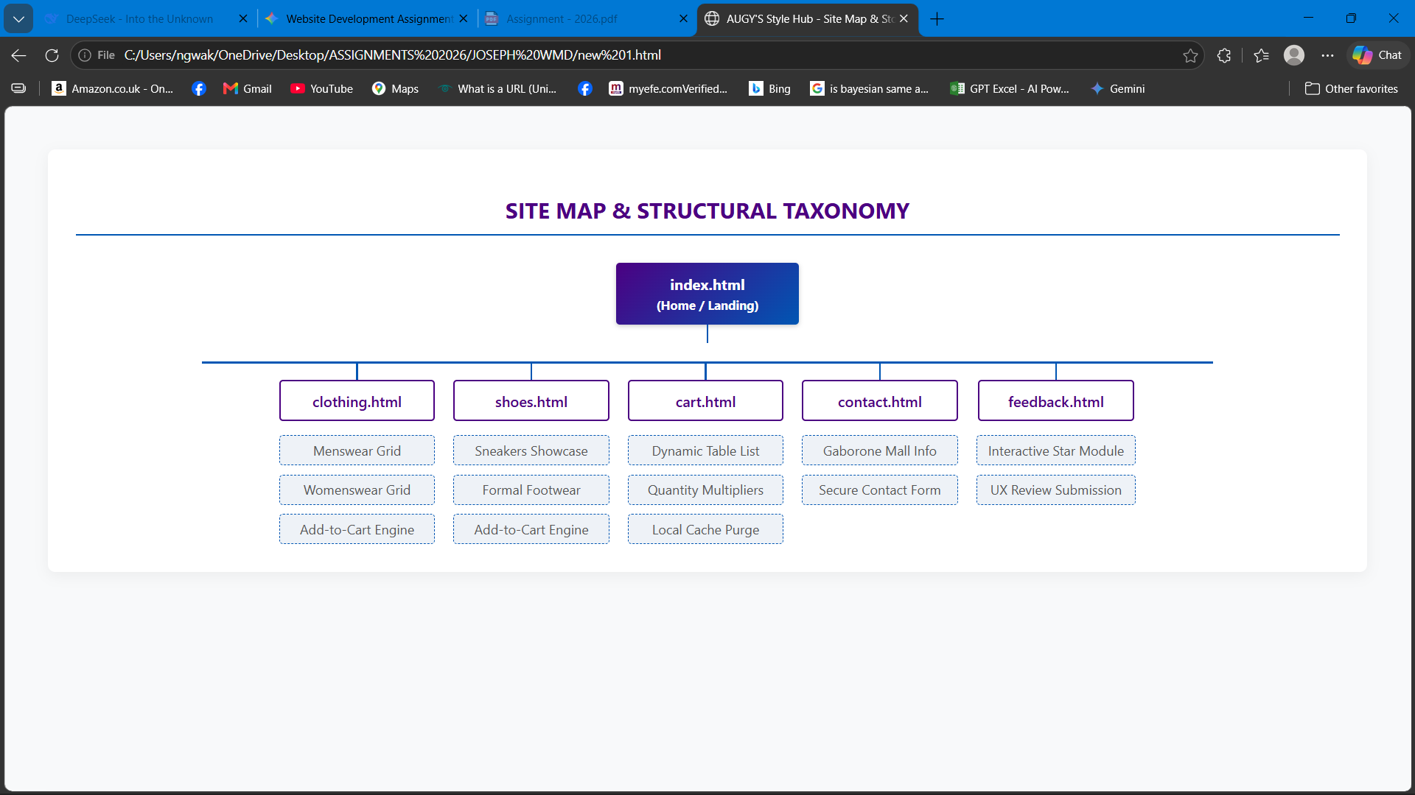
3. Page Template Design (Wireframe Frameworks)
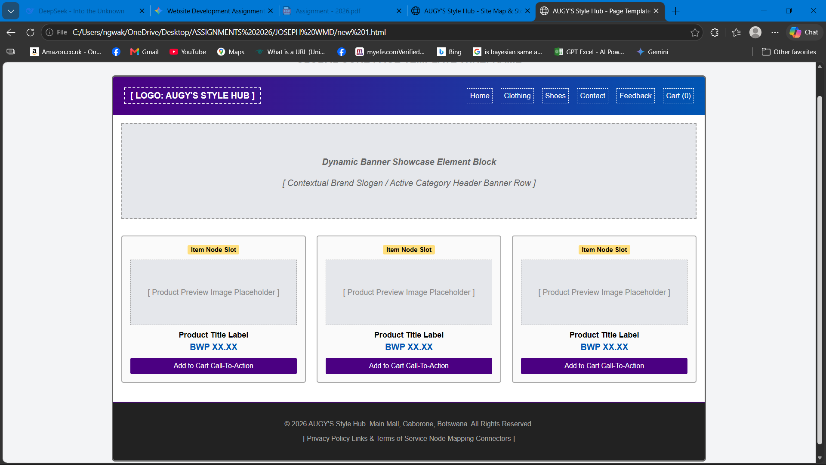
4. Technical Brief
The architecture of AUGY'S Style Hub is designed as a fast, light, and secure front-end client structure using modern tools:
- Structural Layer (HTML5): Semantic document tags (<nav>, <section>, <footer>, <article>) are integrated to establish structural integrity, clean indexing accessibility, and clean component definitions.
- Presentation Layer (CSS3 and Bootstrap 5.2.3): Built using an advanced, production-ready fluid grid layout system. Features a linear-gradient canvas mix (#4B0082 to #0056b3) that offers high contrast, beautiful interactive drop-shadow layers, and clean layout properties across all viewports.
- Behavioral Layer (JavaScript ES6): Logic controls use application state event tracking. The shopping catalog scripts intercept click hooks via data attributes (data-id, data-name, data-price), dynamically compiling item arrays within the browser's persistent localStorage database state machine.
- Development Tools: Engineered using Visual Studio Code (VS Code) for source code file compilation and optimization.
- Graphics and Vector Frameworks: Enhanced with FontAwesome v6.0.0 vector graphics definitions for icon scalability without performance overheads.
5. Quality Assurance (Testing Strategy)
Test ID | Objective | Environment / Browser | Evaluation Context | Results Vector
QA-01 | Cross-Browser Compatibility | Google Chrome v120.0 | Rendering behavior of navbar gradient and catalog alignments. | PASS — Flexbox boxes align exactly to design layout bounds.
QA-02 | Cross-Browser Compatibility | Microosoft Edge v119.0 | Local CSS file overrides and Bootstrap layout engines. | PASS — Font sizes and margins preserve scale consistency.
QA-03 | Mobile Viewport Check | Apple Safari (iOS Mobile) | Testing collapse-toggle navbar drawer mechanics on mobile views. | PASS — Hamburger menu button fires smoothly.
To ensure high accessibility, you should structure your manual tests into a structured verification tracking log matrix:

QA-CROSS BROWSER COMPATIBILITY
CHROME
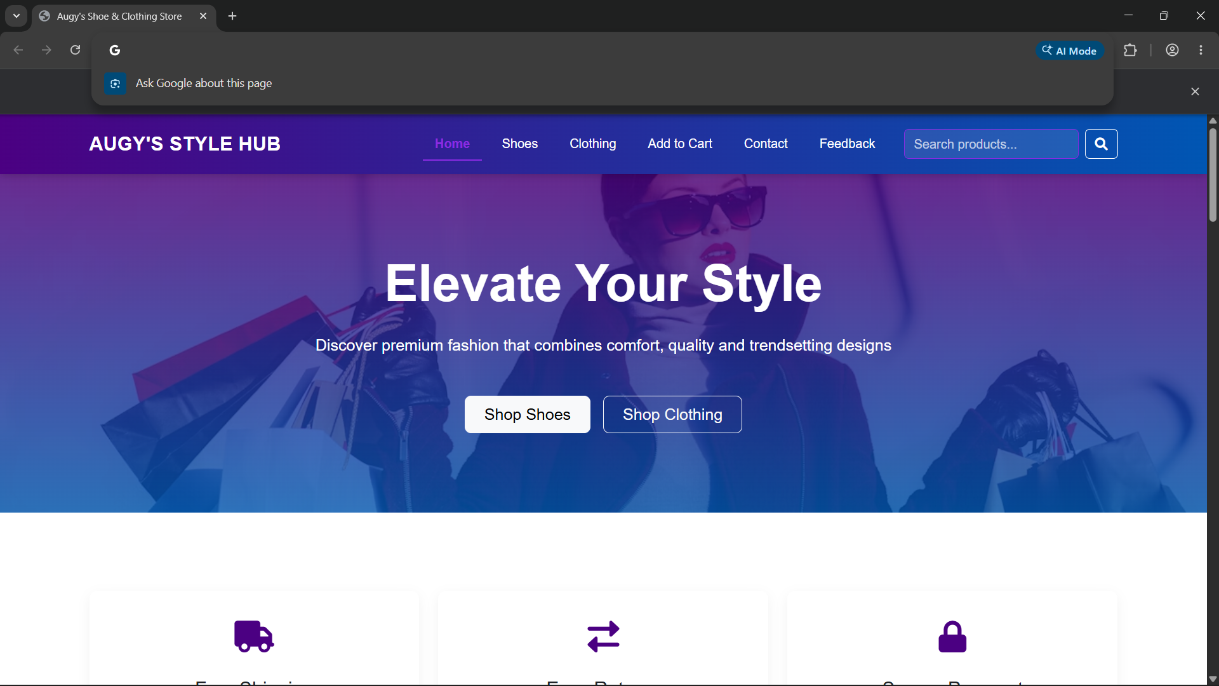

MICROSOFT EDGE
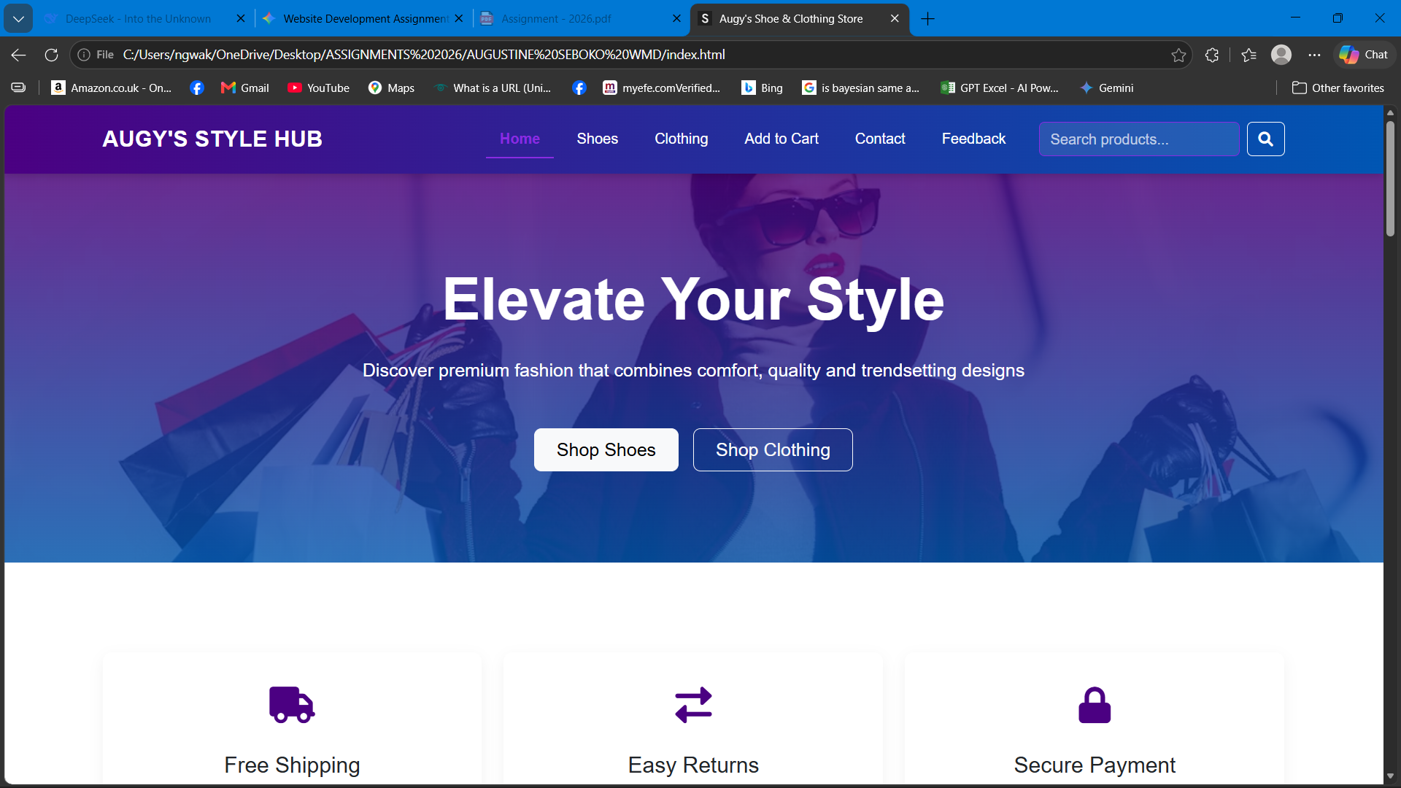
MOBILE RESPONSIVESNES
IPHONE 12 PRO
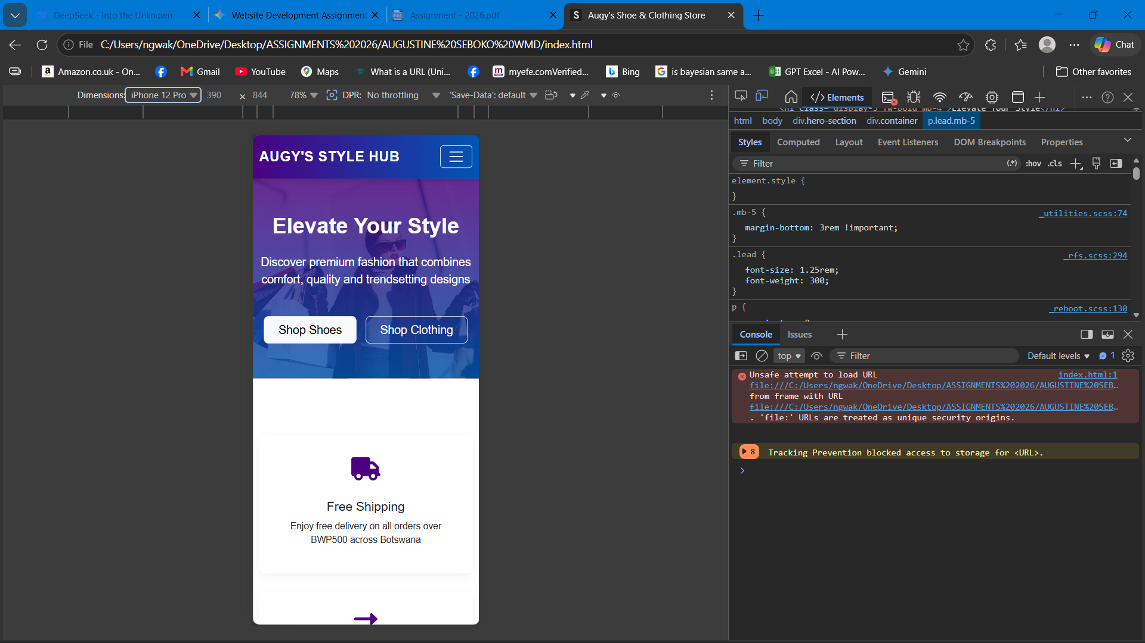
6. Publishing and Promotion
The website platform is fully compiled and hosted online using clear deployment pipelines.
- Hosting Architecture Platform: Hosted via GitHub Pages, providing distributed content delivery network edge performance and uptime tracking.
- Version Control Methodology: Deployed via terminal command executions linking the project folder scope directly into the remote cloud environment repository.
- Core Git Deployment Commands Utilized:
git init
git add .
git commit -m "Deploy production website files for AUGY Style Hub"
git branch -M main
git remote add origin https://github.com/augustineseboko.git
git push -u origin main
- Active Project Hyperlink Reference Targets:
  - GitHub Workspace Repository URL:
  - Live Web Application URL Instance:
7. Future Developments and Recommendations
While the built structural architecture functions flawlessly as a fast storefront, future framework expansions could include:
- Server-Side Database Integration: Migrating local JavaScript cart object arrays from internal client memory buffers over to persistent relational cloud servers (such as PostgreSQL or MongoDB) via an Express API layer. This will enable user profiles and cross-device cart persistence.
- Payment Gateway Integration: Connecting localized financial APIs (such as Orange Money, DPO Group, or FNB Virtual Card secure gateways) directly to the dynamic checkout interface, moving the site from an informational catalog to an automated payment platform.
- Advanced Filtering Analytics and Sorting Pipeline: Upgrading product viewing grids with dynamic sorting filters (sorting items by descending price order, size metrics, or text searches) to improve UX speed as the inventory expands.

